Table Of Contents

Thunderstorm Formation 2
Thunderstorm Types 4
Multi-Cell 4
Squall Lines 4
Supercells 5
Precipitation Formation 6
Hail 7
Damaging Winds 7
Derechos 8
Tornados 8

Thunderstorm Formation

In the life cycle of a typical thunderstorm, warm, moist air is lifted to the lifted condensation level where it condenses and becomes a cloud. The parcel will rise until it reaches warmer, drier air called the cap.
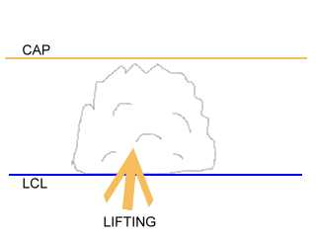
If further lifting force is available, the parcel may continue through the cap to a level where the parcel will encounter cooler, moist air and be free to continue to rise. This level is the Level of Free Convection.
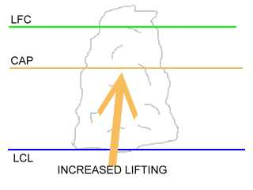

As the parcel continues to rise, an updraft column forms and more warm, moist air is lifted into the tower. This tower may increase in height until it reaches the equilibrium level, where it may encounter the jet stream, where the top of the cell will be blown downstream forming an anvil shape. At this height, the water droplets are becoming greater in number and coalesce into larger droplets. The larger droplets will fall to the surface as rain or hail. If the tower reaches the jet stream or other strong mid level winds, the precipitation will be propelled out in front of the cell.
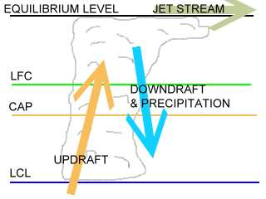
As the inflow to the cell weakens or is overcome by the downdraft, the cell will become downdraft prominent and precipitation will continue for a short period of time. The detached anvil will be all that remains of the cell.

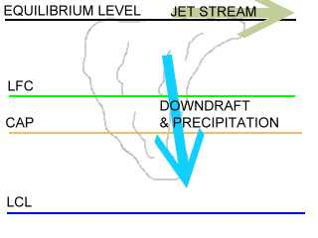

Thunderstorm Types

Multi-Cell

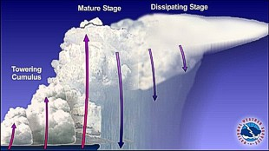
Although there are times when a thunderstorm consists of just one ordinary cell that transitions through its life cycle and dissipates without additional new cell formation, thunderstorms often form in clusters with numerous cells in various stages of development merging together. Unlike ordinary single cells, cluster storms can last for several hours producing large hail, damaging winds, flash flooding, and isolated tornadoes.

Squall Lines

Sometimes thunderstorms will form in a line which can extend laterally for hundreds of miles. These "squall lines" can persist for many hours and produce damaging winds and hail. The rain cooled air or "gust front" spreading out from underneath the squall line acts as a mini cold front, continually lifting warm moist air to fuel the storms.
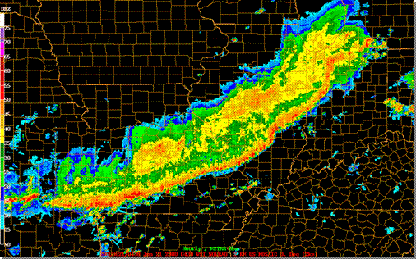

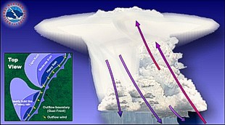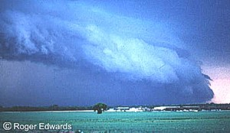

Schematic of a squall line (left) and accompanying photograph (right). Often along the leading edge of the line a low hanging arc of cloudiness will form called the shelf cloud. Gusty, sometimes damaging outflow winds will spread out horizontally along the ground behind the shelf cloud.

Supercells

Supercell thunderstorms are a special kind of single cell thunderstorm that can persist for many hours. They are responsible for nearly all of the significant tornadoes produced in the U.S. and for most of the hailstones larger than golf ball size. Supercells are also known to produce extreme winds and flash flooding.

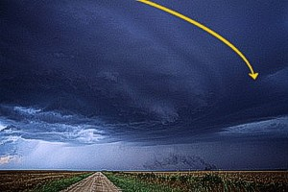

They are characterized by a rotating updraft (usually cyclonic - above left) which results from a storm growing in an environment of significant vertical wind shear. Wind shear occurs when the winds are changing direction and increasing with height. The most ideal conditions for supercells occurs when the winds are veering or turning clockwise with height. For example, in a veering wind situation the winds may be from the south at the surface and from the west at 15,000 feet (4500 m). Beneath the supercell, the rotation of the storm is often visible as well (above right).

The lowering in the photograph below represents the wall cloud. The wall cloud is sometimes a precursor to a tornado. If a tornado were to form, it would usually do so within the wall cloud.

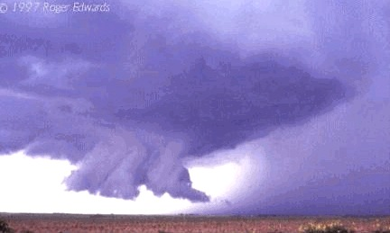

Precipitation Formation

Air is able to hold a definite amount of water vapor. The percentage of water vapor present in the air compared to the maxim amount the air can hold is the relative humidity. When the relative humidity reaches 100%, the air is saturated and cannot mix with more water vapor. The temperature at which this saturation occurs is called the dewpoint. If the temperature drops to the dewpoint, saturation occurs. A drop in air pressure will raise the dewpoint possibly to the point it equals the air temperature and saturation will occur. When the air becomes saturated, droplets will form easily if there are tiny particles of dust or other impurities in the air for the water molecules to “stick” to. These particles are called nuclei. If conditions are present that allow the air to remain saturated, clouds will form. Air parcels reaching the Level of Free Convection will have enough moisture to continue cloud development. As more droplets coalesce, larger droplets will form and eventually become too heavy for the

updraft to hold aloft and they will fall as rain. It is also possible for the droplets to be blown ahead of the clouds by upper level winds.

Hail

At high altitudes it is possible for ice nuclei to cause water droplets to freeze and form ice crystals. As these ice crystals move around and contact supercooled pure water droplets the water droplets will freeze to the ice crystal in a process known as riming. The ice crystals can continue to grow through this process until they are too heavy for the updraft to support and will fall to the surface as hail. They may also be blown downstream by upper level winds or get caught in the RFD of a mezzo.

Damaging Winds

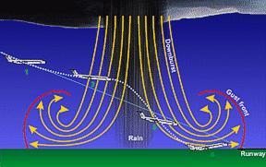
Damaging wind from thunderstorms is much more common than damage from tornadoes. In fact, many confuse damage produced by "straight-line" winds and often erroneously attribute it to tornadoes. Wind speeds can reach up to 100 mph (161 km/h) with a damage path extending from hundreds of miles.
Several factors contribute to damaging winds at the surface. As precipitation begins to fall, it drags some of the air with it. This "precipitation drag" initiates a downdraft. The downdraft is intensified by evaporative cooling as drier air from the edges of the storm mix with the cloudy air within the storm. This can be very hazardous to aircraft in flight.
Also some of the strong winds aloft are carried down with the downdraft by a process called "momentum transfer". These processes lead to a rapid downward rush of air. As the air impacts the ground it is forced to spread out laterally causing the gusty and sometimes damaging winds associated with thunderstorms.

Derechos

A derecho happens when a squall line ingests warm, dry high-level jet streams and as precipitation falls through it, evaporative cooling occurs. The air parcels cool, become negatively buoyant, and an intense downburst occurs, directing jet-stream winds to ground level. Derechos may last for many minutes or hours as long as the above conditions are met.

Tornados

A tornado is a violently rotating column of air descending from the base of a thunderstorm and in contact with the ground. Although tornadoes are usually brief, lasting only a few minutes, they can sometimes last for more than an hour and travel several miles causing considerable damage.

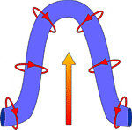
Most tornadoes are spawned from supercell thunderstorms. Supercell thunderstorms are characterized by a persistent rotating updraft and form in environments of strong vertical wind shear. Wind shear is the change in wind speed and/or direction with height.

The updraft lifts the rotating column of air created by the speed shear. This provides two different rotations to the supercell; cyclonic or counter clockwise rotation and an anti-cyclonic of clockwise rotation. The directional shear amplifies the cyclonic rotation and diminishes the anti-cyclonic rotation (the rotation on the right side of the of the updraft in the illustration at left). All that remains is the cyclonic rotation called a mesocyclone. By definition a supercell is a rotating thunderstorm.

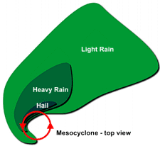
When viewed from the top, the counter-clockwise rotation of the mesocyclone gives the supercell its classic "hook" appearence when seen by radar. As the air rises in the storm, it becomes stretched and more narrow with time.

