Introduction

The purpose of this manual is to educate the new spotter in safety, Midwest SSTRC Inc. protocol, and identifying basic storm features.

Table Of Contents

The Spotter’s Role 2
National Weather Service Capabilities 2
Reporting Severe Weather 3
Midwest SSTRC Inc. Deployment Protocol 3
Severe Weather Criteria 5
Aloft Events 5
Non-Aloft Events 5
Reporting Format 6
Optional Reporting Methods 6
Safety 7
Preparing For Severe Weather 7
Lightning Hazards And Safety 7
Hail Hazards And Safety 8
Tornado And High Wind Safety 8
Flooding Hazards And Safety 9
The Thunderstorm Life Cycle 10
Thunderstorm Categories 11
Identifying Thunderstorm Features 11
Downbursts 14
Tornadoes 15
Tornado Look-alikes 17
Further Education Resources 18

The Spotter’s Role

Storm spotters are trained individuals whose purpose is to assist in providing early detection of severe weather that may result in the loss of life or property. This information is communicated to government officials and other recognized agencies and organizations including the National Weather Service. This helps allow for timely public severe weather warnings and providing emergency response as appropriate.

Trained spotters learn about the physical structures of severe storms and how to identify the areas most likely for severe weather development. Trained spotters also learn to identify visual clues that may precede tornado development as well as distinguish real tornados from tornado look-alikes.

National Weather Service Capabilities

Although modern technology provides the National Weather Service with tools to prepare severe weather warnings, storm spotters provide real-time details of what is actually happening in and around severe storms. Doppler radar is able to detect the speed and direction of thunderstorm cells as well as rotation within the cells, however it has some physical limitations.

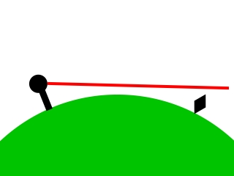

One example of these limitations is the curvature of the earth. The radar beam generally travels in a straight line and as it gets further from the radar the earth falls away from the elevation of the beam making it impossible to detect low level storm features.

Reporting Severe Weather

During periods of severe weather, making accurate, timely, and organized reports of your observations is critical. The Manager On Duty will have many activities occurring at once: taking member status reports, contacting officials, organizing the net, and often acting as the Nowcaster and Net Control. Below is the method by which Midwest SSTRC Inc. deploys its spotter network. If you are unable to be a part of the network and you observe severe weather, there are other means by which you may make a report. As a member of a recognized spotter group, please follow this protocol carefully.

Midwest SSTRC Inc. Deployment Protocol

The Nowcaster will notify the MOD of threatening conditions at least 2 hours before
an event could occur or when a thunderstorm or tornado watch is issued for a
county or areas nearby. The MOD will make the call to bring up the MidWest SSTRC Inc. net as he or she deems fit. Many times the MOD and Nowcaster are one and the same.

The MOD is responsible for contacting county EOC personnel to let them know MidWest SSTRC Inc. has activated and when it deactivates.

The MOD will set up the net by sending an email to everyone via the email group and making an announcement on the radio frequencies. We no longer will be making phone calls to each member.

It is the responsibility of the members to pay attention to the email group and
contact the MOD by email or radio. You should tell the MOD if you are available and what equipment is available to you (cell phone, radio, etc). You will also need to let the MOD know if you are static or mobile. If you are mobile, you must have a radio or be paired up with someone who does. With exclusive exceptions, no one shall be mobile by themselves, you must have a partner! The MOD will help pair you
with someone to spot with. This has to occur BEFORE a Condition Red.

For now, the base operations will be run by a member of the core deployment
group or the MOD. You will be contacting him or her for deployment instructions.

Each spotter is responsible for their own actions. In no way will MidWest SSTRC Inc. be held accountable to the actions of a spotter. Be safe at all times!

1. All Clear- (Condition Cyan)
No severe weather expected in the next 72 hours. Threat of severe weather has passed or ended. Severe weather has moved out of our coverage area.

2. Informational Mode- (Condition Blue)
Members communicate via e-mail. The Nowcaster predicts severe weather within the 2-3 day convective window put out by the SPC.

3. Standby Mode- (Condition Green)
Day 1 data confirms prediction in 24 hour outlook. Units monitor e-mail
and maintain a high state of readiness in anticipation of deployment, including planning their day with partners if mobile spotting and updating availability. It is not
necessary to update in the informational mode unless units are going to be in a
planned absence, either over the period of concern or for periods greater than 24 hours.

4. Ready Mode- (Condition Yellow)
Adjacent immediate area looks compromised, or unsettled but severe weather is
unsure, or adjacent areas -nearby states or closer (counties nearby on a Short Fuse warning, pop-ups etc.) are warned.
Actions depending on speed and distance for a core group (1-2) of experienced
volunteers may be deployed for observation beyond county borders in an area of concern where information is unclear.
The observers will report their observations to the MOD -via radio, cell or land-line (depending upon availability) for a further determination. (This also provides for some coverage if the situation turns short fuse.)
Usage of the radio frequencies is normal traffic. Announcement by the
MOD are made indicating that the MidWest SSTRC Inc. net could go into Condition Red at any time. Any planning for sharing rides, etc should be made now as this type of communication during a condition Red may not be allowed. All members should finish posting their status now. Doing it during a Condition Red is too late.

5. Activation- (Condition Red)
Activating the Net happens if severe weather is imminent or if conditions warrant as
decided by the MOD. Communications on the radio frequencies will be restricted to severe criteria reports and communications only. The MOD or Net Control person will take control of the Ham frequency and regulate its usage. Linking of Ham repeaters may take place at this time. Both repeaters will then be under the full control of the MidWest SSTRC Inc. MOD or Net Control.

MidWest SSTRC Inc. members on the business frequency will also be expected to limit their communications to severe criteria as well. Usage of T.L.C.S. format is required when contacting Net Control with a report. Try not to give additional information unless the MOD/Net Control asks for it. If more information is needed the MOD/Net Control will ask the unit for it. When calling in a report via phone or email we must use the same T.LC.S. format.

6. Stand Down – (Condition to revert to)
The MOD/Net Control operator has brought the MidWest SSTRC Inc. net down. They will indicate which mode we will stand down to.

Severe Weather Criteria

MidWest SSTRC Inc. uses the same severe weather criteria as the National Weather Service. At times the MidWest SSTRC Inc. Net Control Operator will restrict reports and radio conversations to Severe Criteria only.

Aloft Events
When reporting aloft events, report the location of the event with respect to your current location.

- Tornadoes or Waterspouts
- Funnel Clouds
- Rotating Wall Clouds (Rotating at least 30 seconds)

Non-Aloft Events
When reporting non-aloft events, report your current location.

- Winds 50 MPH or higher
- Hail ½ inch or larger. Specify measured or estimated
- Flooding
- Visibility of less than ½ mile
- Rainfall. ¼ inch within 15 minutes or 1 inch in a short period of time. Rain gage reports should include start and end times

Reporting Format

Severe weather reports are given using the T.L.C.S. format.

T = TIME The time the event occurred or is occurring in 12 hour format.

L = LOCATION The distance and compass direction from the nearest city reference point including the county.

C = CONDITION The weather event.

S = SOURCE Your MidWest SSTRC Inc. number and/or FCC call sign.

Example: 7:00 PM, 1 mile E of Monona, Dane Co., tornado 1 mile to my south heading east at approximately 30 MPH, Midwest 100, WX9TRC

Optional Reporting Methods

Spotters who do not have a radio or are out of range for radio communications may contact the Net Controller by telephone or call the National Weather Service 800 number. One last resort would be to dial 911. However, 911 centers become quite busy and your report may be delayed in getting to the individuals who need the information.

For reporting non-critical, non time-sensitive observations after an event you may use the National weather Service’s eSpotter program. Through this online reporting system you can make direct reports to the National Weather Service. This information is useful to the NWS in helping them confirm reports received by other spotters. Visit the NWS website for details.

Safety

A storm spotter’s accurate and timely report is critical to communities and the National Weather Service, however, the spotter’s number one priority is his or her own safety. Severe weather produces several hazards, all of which can lead to injury or death. As a spotter with basic training, you will be making observations from a static location such as your home or business. Mobile spotting is reserved for spotters with advanced spotting skills. You may however, make arrangements with an advanced spotter to ride along during an event. Remember: spotting can become extremely dangerous at any time. BE SAFE!

Preparing For Severe Weather

Being aware of the potential for severe weather in your area is the best way to protect yourself from becoming a victim of severe weather hazards. Here are a few ways you can prepare yourself:

- Pay close attention to weather forecasts and check periodically for updates
- Obtain and use a weather alert radio
- When severe weather is imminent, monitor local TV and radio broadcasts and seek a means of shelter.

Lightning Hazards And Safety
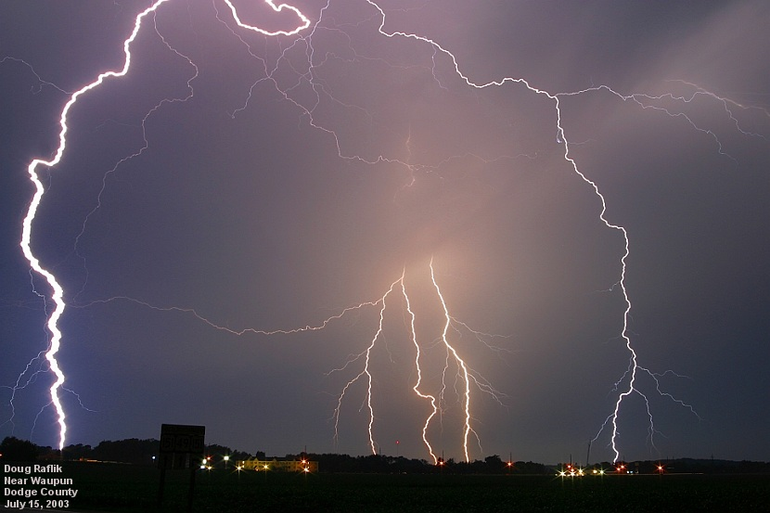
All thunderstorms produce lightning, and people are killed and injured each year by lightning. Storm spotters may put themselves at risk from lightning by being in the open, being on a hill or high spot (for better visibility), parking or standing next to metal fences or underneath power lines, standing close to camera tripods or using radio equipment attached to antennae.
Lightning can strike as far as 10 miles

from a thunderstorm- about the distance you can hear thunder. If you can hear thunder, you are within striking distance. Follow these basic lightning safety guidelines:

- Avoid being the tallest object, and stay away from other tall objects (like trees, power poles/lines)

- Don’t stand close to fences or power poles/lines. Even though you may not be in an area of frequent lightning, lightning can travel a considerable distance along these pathways.
- If possible, take shelter inside a building or vehicle. Once inside, stay away from doors and windows and avoid anything that conducts electricity, such as plumbing.

- Avoid the use of electrical appliances.

Hail Hazards And Safety

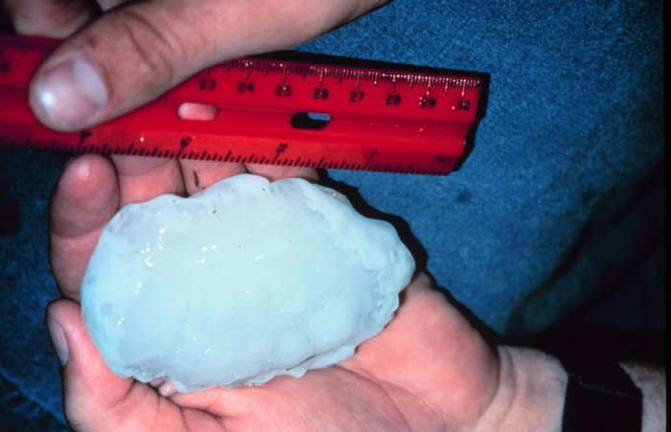
The greatest danger from hail is impact at a high velocity. Hail can vary in sizes as small as a pea to as large as a grapefruit. Large hail can fall at speeds over 100 MPH.

- Seek shelter immediately
- Stay away from windows
- If caught outdoors, cover and protect your head by any means available
NOAA Photo

Tornado And High Wind Safety

Get underground or into a safe room or basement if possible. If none of these are available, get on the lowest floor of a sturdy building, putting as many walls between you and the outside as possible. Avoid windows, doors and outside walls.

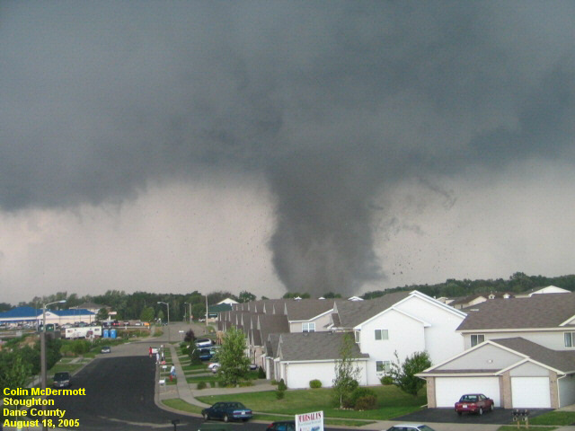
Cover your head and body to protect yourself from deadly flying debris. Mobile homes and vehicles should be abandoned for more substantial shelter.

Flooding Hazards And Safety

Flooding is one of the most deadly weather hazards killing an average of 140 people in the United States each year. Flooding occurs with heavy rainfall in slow moving and stationary storms and can occur with little warning. Six inches of fast moving water can knock you off your feet and 2 feet of moving water can carry away a vehicle.

- Seek higher ground
- Do not walk through floodwaters
- Do not drive through floodwaters- the road may be washed away
- Stay away from the banks of floodwaters

The Thunderstorm Life Cycle

There are three basic stages to the thunderstorm life cycle :

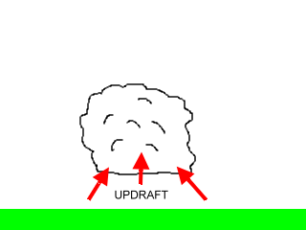

The cumulus stage – Warm, moist air rises and begins to condense and form clouds. This stage consists of only the updraft air movements. These updrafts reach heights of around 20,000 feet above the ground.

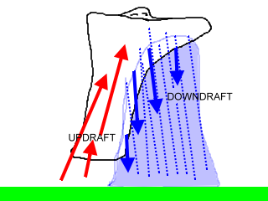
The mature stage - At this stage, the storm contains both upward and downward moving air currents (updrafts and downdrafts) with precipitation in the downdraft area. The downdraft results from precipitation evaporating, which causes cooling. To a lesser extent, the falling precipitation itself creates downward drag. When the cool downdraft hits the ground, it spreads out and forms a gust front, which may include damaging winds called a downburst. At the top of the storm, the updraft rapidly decelerates and clouds spread out and form an anvil. If the updraft is strong, a “bubble” of cloud, called an “overshooting top,” will be pushed above the anvil. Spotters should pay particular attention to a storm with an overshooting top since the area beneath the top is a preferred area for severe weather formation.

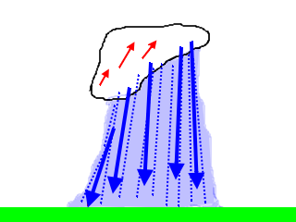

The dissipating stage – Eventually, excessive precipitation and downdraft will weaken the updraft. Downdrafts dominate the storm and any overshooting top disappears. At the surface, the gust front will move away from the storm and cut off the inflow of energy into the storm.

Thunderstorm Categories

Depending on the type and number of cells, thunderstorms may be divided into four main categories:

• Single-cell storms are generally weak, short-lived, and poorly organized.

• Multi-cell cluster storms are the most common type of storm and consist of a series of cells moving along as one unit.

• Multi-cell line storms, commonly called “squall lines,” consist of a long line of storms with a continuous gust front at the leading edge.

• Supercell storms have a single updraft, are very strong, and always produce significant severe weather.

Identifying Thunderstorm Features

There are several visual clues to the updraft strength and organization of a thunderstorm that will help a spotter determine the possibility of severe storm potential. These clues are evident at the upper, middle and lower levels of the thunderstorm.

Upper-Level Storm Clues — These clues are best seen at a distance of 30–40 miles from the storm, so they may be difficult to see in poor visibility areas. The primary clues are a large overshooting top that persists for more than 10 minutes and an anvil with sharp and well-defined edges. Storms with weaker updrafts will
usually have an anvil that is thin, wispy, and fuzzy.

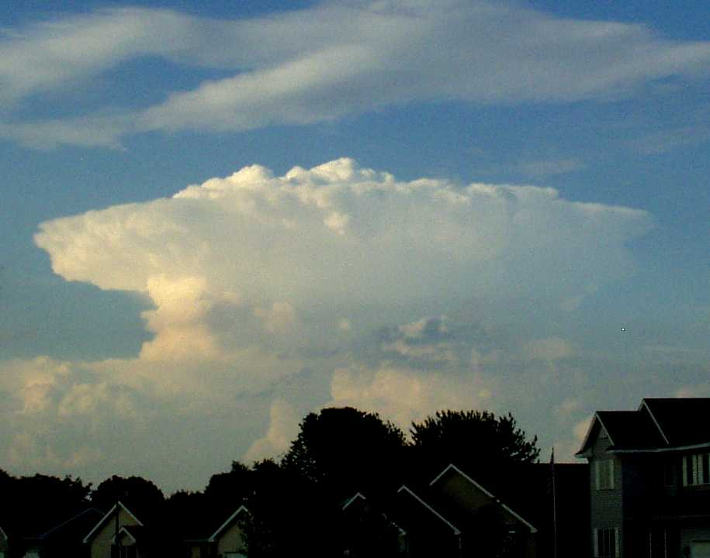
Todd Davidson

Mid-Level Storm Clues — These clues are best seen at a distance of 10–20 miles from the storm, and again, some of these features will be difficult to see in poor visibility areas. These features are concentrated in the main storm tower area. The primary clues are the following.
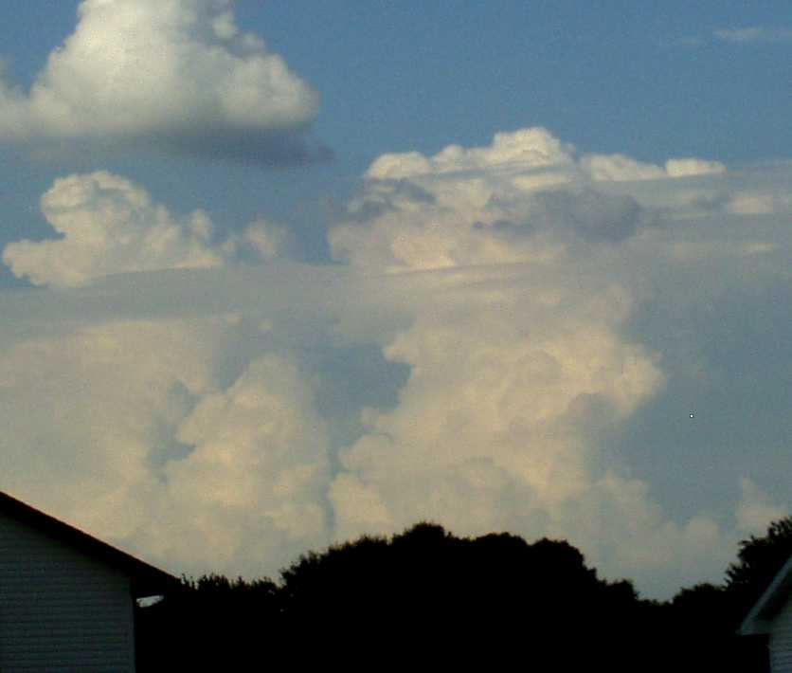

• A solid appearing updraft tower with a sharp, cauliflower definition in the storm tower. Some storms have a soft or “mushy” appearance indicative of a weaker updraft and therefore are a poor candidate for producing severe weather.

Todd Davidson

• A flanking line — a row of small cloud towers that build up (stair-step) into the main storm tower from the south or southwest. The flanking line does not suggest updraft strength, but it does indicate storm-scale organization necessary for persistent severe weather.

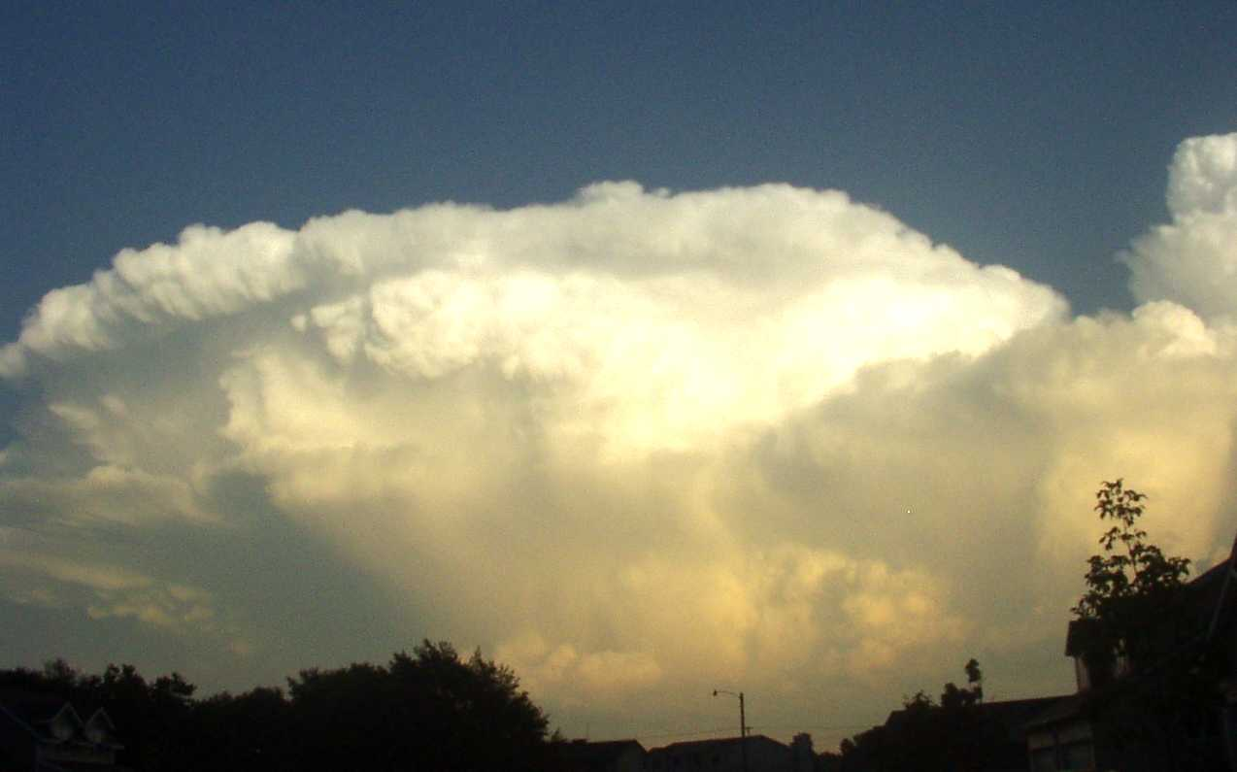
Todd Davidson

Low-Level Storm Clues — These clues are best seen at a distance within 10 miles of the storm and are the easiest clues to detect in lower visibility areas. Low-level storm features can be the most critical in determining a storm’s severe potential but can result in the most confusion among storm spotters. The primary clues are the
following.
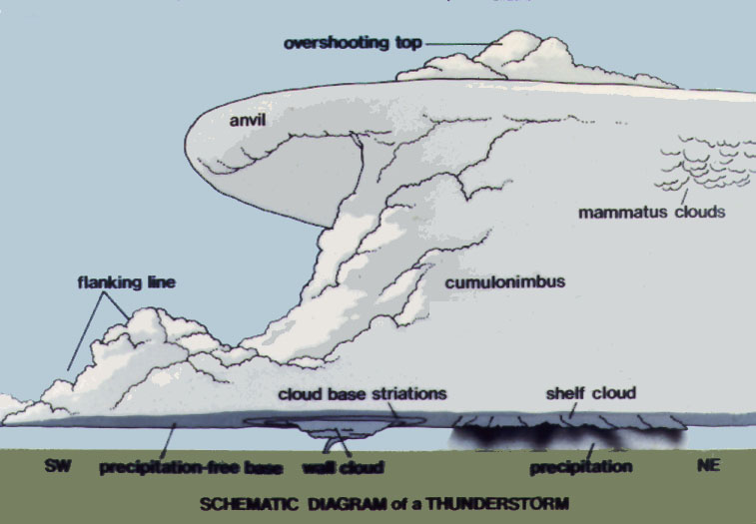

• The rain-free base — a low, flat cloud base from which little visible precipitation is falling. However, the precipitation in this area is often in the form of large hail. The rain-free base defines the primary inflow and updraft area in the storm. The preferred area for severe weather formation is near and just north/east of the rain-free base.

.
National Weather Service

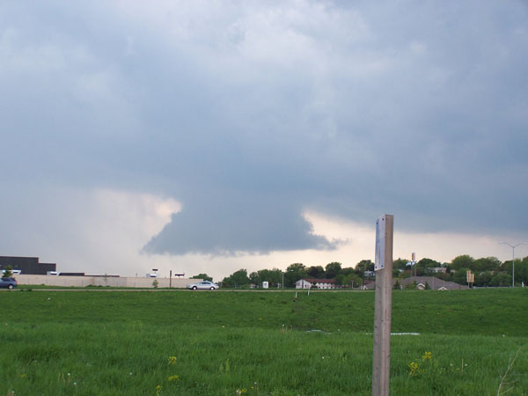
• The wall cloud — an isolated lowering of the rain-free base. It is always attached to the cloud base. It indicates the storm’s strongest updraft area, and it is the primary location for severe weather development. Wall clouds with persistent rotation (10 minutes or more) are especially significant since they denote a very dangerous storm that may produce large hail, strong downbursts, or a tornado.

Frank Weisensel

Downbursts

A downburst is defined as a strong downdraft from a thunderstorm with an outrush of damaging wind on or near the ground. Damaging downbursts, although relatively rare themselves, are much more common than tornadoes. Because of their small size and short lifespan, it is difficult to detect and warn for downbursts.
Downbursts are divided into two categories.
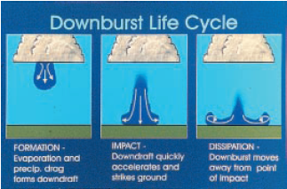

• Macroburst — Swath of damaging wind is 2.5 miles or more wide.

• Microburst — Swath of damaging wind is less than 2.5 miles wide.

The initial stage begins as the downburst starts to descend from the cloud base. The second stage, called the “impact” stage, occurs when the
National Weather Service
downburst makes contact with the ground and begins to spread outward. Expect the strongest wind speeds shortly after the downburst hits the ground. The impact stage is also the most dangerous stage for aviation as aircraft caught in the strong winds may see wing lift decreased, possibly causing the plane to stall and crash. “Dissipation,” the final stage, occurs when the downburst spreads out and weakens. Beware, other downbursts may form later.

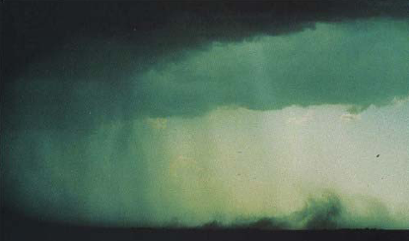
One of two primary ways to detect a downburst is to spot a rain foot. The rain foot is a pronounced outward deflection of the precipitation area near the ground, marking an area of strong outflow winds. The second identification method is the presence of a dust foot, a plume of dust raised as the downburst reaches the ground and moves away from the impact point. The dust foot is most common in the High Plains, western states, and over plowed fields.
National Weather Service

Tornadoes

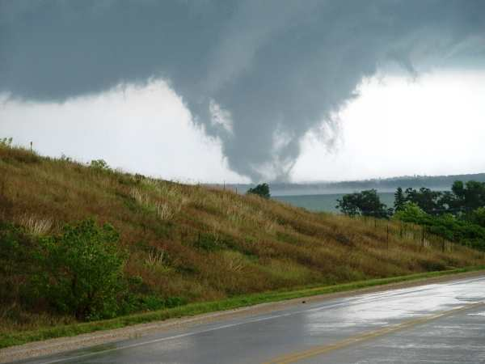
Dale Bernstein

A tornado is a violently rotating column of air in contact with the ground and extending from the base of a thunderstorm. A condensation funnel does not need to be present or if it is present, it does not need to reach the ground. Only the presence of a debris cloud beneath the thunderstorm confirms there is a tornado.
Tornadoes exist in many different shapes, sizes and strengths. Tornadoes are rated by the amount of damage they create using the Fujita scale. The Fujita scale estimates the wind speeds based on the amount of damage the tornado created.

SCALE | WIND ESTIMATE *** (MPH) | TYPICAL DAMAGE
F0 | < 73 | Light damage. Some damage to chimneys; branches broken off trees; shallow-rooted trees pushed over; sign boards damaged.
F1 | 73-112 | Moderate damage. Peels surface off roofs; mobile homes pushed off foundations or overturned; moving autos blown off roads.
F2 | 113-157 | Considerable damage. Roofs torn off frame houses; mobile homes demolished; boxcars overturned; large trees snapped or uprooted; light-object missiles generated; cars lifted off ground.
F3 | 158-206 | Severe damage. Roofs and some walls torn off well-constructed houses; trains overturned; most trees in forest uprooted; heavy cars lifted off the ground and thrown.
F4 | 207-260 | Devastating damage. Well-constructed houses leveled; structures with weak foundations blown away some distance; cars thrown and large missiles generated.
F5 | 261-318 | Incredible damage. Strong frame houses leveled off foundations and swept away; automobile-sized missiles fly through the air in excess of 100 meters (109 yards); trees debarked; incredible phenomena will occur.

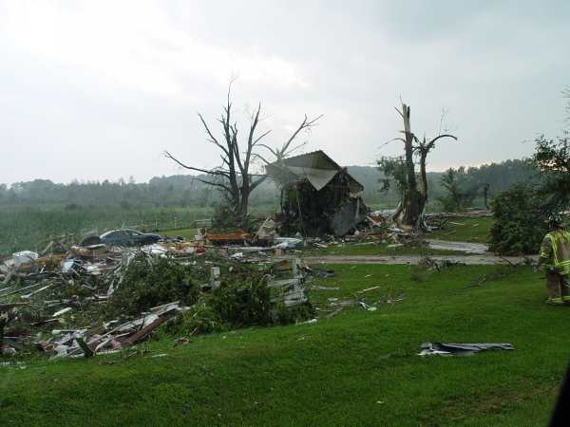

Keep in mind that a slow moving tornado with 120 mph winds can do as much damage as a fast moving tornado with 250 mph winds.

Dale Bernstein

Tornado Look-alikes

Be very careful when reporting a tornado. Remember - a tornado is a violently rotating column of air in contact with the ground and extending from the base of a thunderstorm. Below are examples of tornado look-alikes.

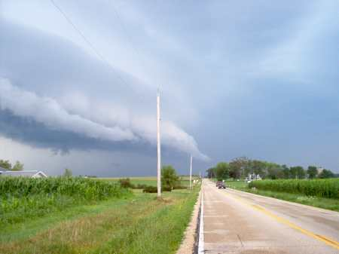
Brent Cook
Tail Cloud

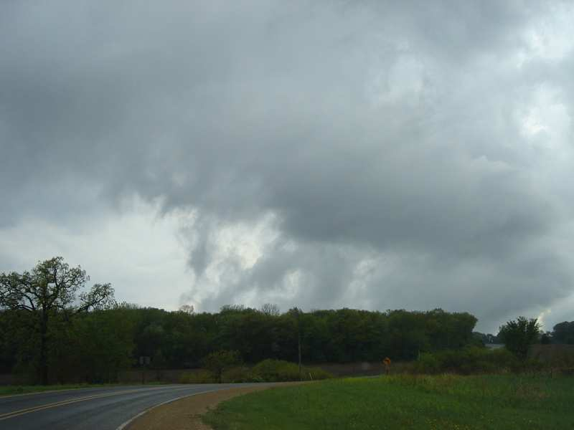
Brent Cook
Scud Clouds

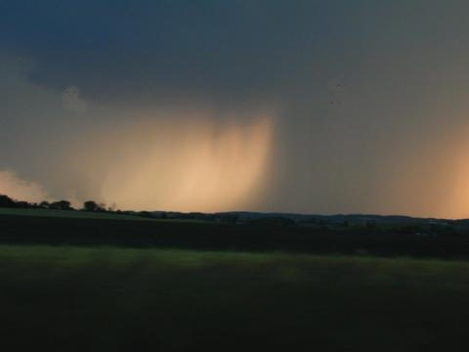
Tom & Lisa Roberts
Rain Shaft

Further Education Resources

The best tool a spotter has is his or her education. Further training materials are available on the internet at the Midwest SSTRC Inc. and National weather service websites.

www.midwestsstrc.org
www.crh.noaa.gov/mkx/spotters.php

